W02 Learning Activity: CSS Box Model
Overview
The CSS Box Model is a box that wraps around every element. From the inside out, the model defines how the content, padding, border, and margin are rendered.
Prepare
Watch the following video:
https://youtu.be/Np1FuPKLb3E?si=0GBNAS74NBMy0o0m
Here is a CSS rule for div elements that defines the width and box model. The content is 400 pixels wide and the height is driven by the actual (but not shown) content, whatever it happens to be.
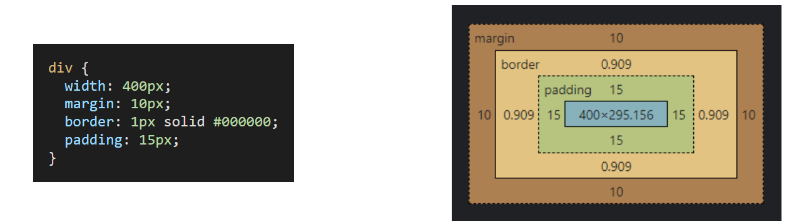
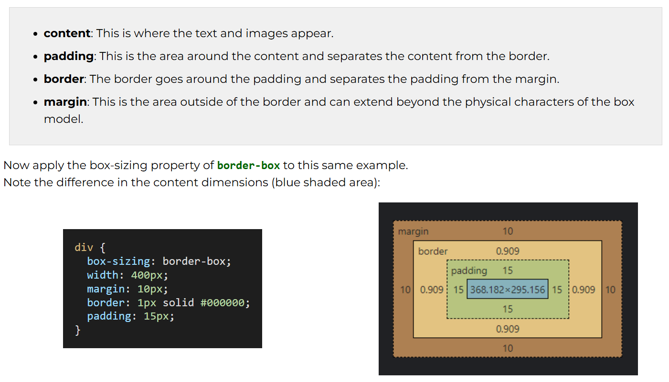
CSS Shorthand Notation
CSS shorthand notation is generally considered best practice for conciseness, readability, and performance. However, longhand notation has its uses and can be more appropriate in certain situations where specificity is needed.
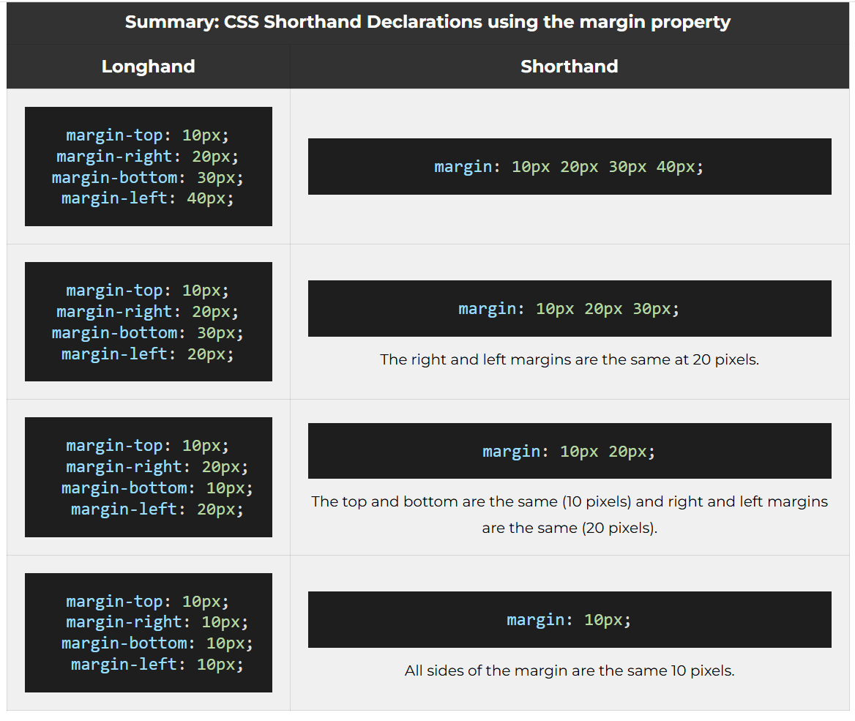
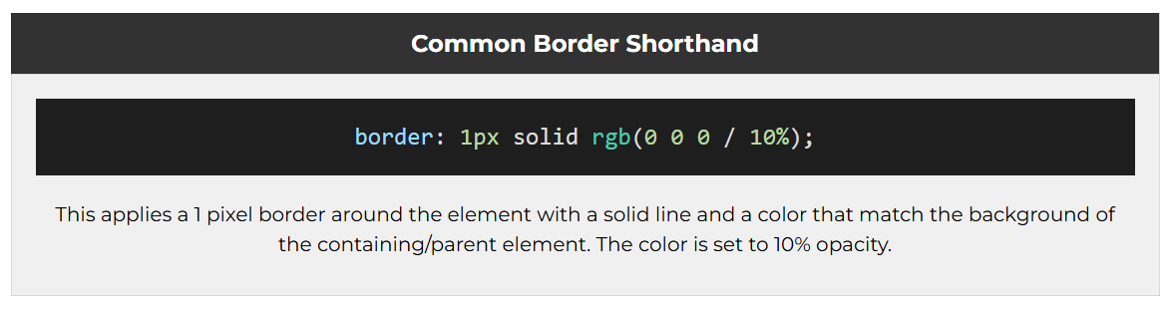
Activity Instructions
Files
- In your week02 folder, open the file named box-model.html.
- In the styles subfolder within the week02 folder, open the CSS file named box-model.css.
HTML
- In the box-model.html HTML file, create a link to the CSS file box-model.css using the <link> tag.
Make sure this <link> element is located within the <head> section.Check Your Understanding
<link rel="stylesheet" href="styles/box-model.css">
- Open the box-model.html file in Live Server or Five Server to view the changes as they happen in this activity.
At this point, the HTML renders as shown here: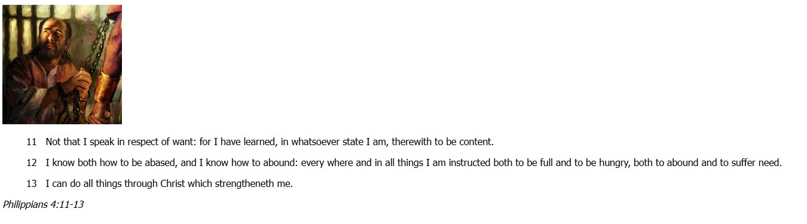Screenshot of Box Model HTML File Rendered in a Browser
CSS
- Use the CSS selectors to style the HTML elements to match the style shown in this image: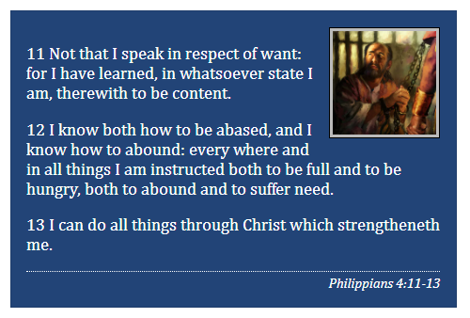Screenshot of Example Solution
- Write CSS declarations to style the HTML elements in the box-model.css file.
Note that the CSS rules have been started with the appropriate selectors.
  - the callout class
  - img element within the callout class
  - blockquote element
  - cite element
Use the following summary of declarations as a guide:
Element | Required CSS Declarations
callout class | maximum width, margin, border, padding, background color, and text color
image | position (float), margin, border, padding, background color, width, height
blockquote | margin
cite | display, top border, top padding, text alignment, size of font
- Compare your work to the example solution provided that is named box-model-solution.html.
Did you notice the semantic HTML elements used to encase the scripture and scripture reference?
The scripture was encased with a <blockquote> element versus a generic <div> or <p> element
The scripture reference was encased with a <cite> element.
There is nothing special about these elements except their semantic names and maybe, default styling by the browser. Otherwise they behave and look like any other block element.
Do not worry if you did not use these in your design. Refactoring work as you discover new elements and methods is part of the overall development process.
Optional Solution Discussion
https://www.loom.com/share/69d2ac1c56ee4e54a00e9dc195cb1419

